Functions:
Functions are a very powerful feature in SQL. It can do
- Perform calculations on data
- Modify individual data items
- Manipulate output for group of rows
- Format dates and numbers for display
Single Row functions - Single row functions are the one who work on single row and return one output per row. For example, length and case conversion functions are single row functions.
Multiple Row functions - Multiple row functions work upon group of rows and return one result for the complete set of rows. They are also known as Group Functions.
- AVG
- COUNT
- MIN// age
- MAX// age
- SUM
- STDDEV
- VARIANCE
Example:
Select AVG(col_name) from Table_name
Select AVG(salary) from employees
Select Min(salary) from employees
Select Max(salary) from employees where department_ID=90
Select sum(marks) from Student where stud_name=’ abc ’// total

Single-row functions:
- Character Function.
- Number Function.
- Date Function.
- Conversion Function
- General Function.
Character functions:
- Case Manipulation function
- Lower
- Upper
- Initcap
- Character Manipulation function
- Concat
- Substring
- Length
- Instring
- Replace
- Trim “ Abc “
- Lpad/Rpad
Number Functions:
- ROUND// 7589.50--- 7590
- TRUNC
- MOD
- FLOOR
- CIEL
Date Function:
- Months-Between
- Add-months
- Next-day
- Lastday
- Round
- Trunc
Conversion functions:
- Implicit Datatype conversion
- Explicit Datatype conversion
General functions:
- NVL
- NVL1
- NULLIF
- COALASCE
Case Manipulation Function:
lower, UPPER, Initcap:
Select last_name, lower(last_name), job_id, initcap(job_id), first_name, upper(first_name) from employees

Last_name, Last_name, Job_id, Job_id, First_name, First_name
Character Manipulation function:
Concat function:
select concat(first_name,concat(' ',concat('is working as',concat('',JOB_ID)))) as Details from employees where first_name='Lex'
Select first_name concat(‘is a’, concat(Last_name)) from employees;
Substring:
select substr('HELLOWORLD',6,7) from dual// substr//or
select substr('HELLOWORLD',-6,7) from dual

select * from employee_sample2 where substr(emp_name,1,1)='a'
select * from employees where substr(last_name,-2,2)='in';
select * from employees where substr(hire_date,-2,2)='89';
select * from employees where substr(last_name,-3,4)='rra';
Length: length()
Used to find the length of a string.
Select * from employees where length(first_name)=10;
select * from employees where length(first_name)=3 and length(last_name)=7;

Instring
Select instr('CHENNAI','N',2,1) from dual;
Select instr('assassination','i',3,2) from dual;
Select * from employees where instr(first_name,'r',-1,1)=length(first_name);
Replace:
Replace particular letter or character with another in a string
Select replace('Helloworld','o','&') from dual;// Hell&w&rld
Select replace('Helloworld','l','L') from dual;
Select replace(first_name,'e','H') from employees;
Select replace( replace(first_name,'e','H'), 'n','M') from employees;
Trim:
Trim();//java
Used to remove first and last characters of a string. Space also considered as character.
Select trim('h' from 'helloworld') from dual;// elloworld
select trim('A' from first_name) from employees where first_name like 'A%'// Abi
//Anitha bi// nitha
select trim('K' from first_name), trim('K' from last_name) from employees where first_name='Ki' or last_name='King'
LPAD:
select lpad(first_name,10,'*') from employees
Result: ******King
RPAD:
select rpad(first_name,10,'*') from employees
select Rpad(first_name,10,'^') from employees
NUMBER FUNCTIONS:
ROUND: Rounds-off the decimal value to nearest integer
select round(9.454) from dual - output: 9
select round(9.654) from dual - output: 10
TRUNC: Removes the values after the decimal point
select trunc(9.4544657) from dual – output: 9
select trunc(9. 4544657,3) from dual – output: 9.454
MOD: Displays the reminder after division %
select mod(9.454,3) from dual – output: .454
select mod(9.454,2) from dual – output: 1.454
CEIL: Rounds off to the next highest integer.
select CEIL(9.454) from dual// 10
FLOOR: Rounds off to the next smallest integer
select FLOOR(9.954) from dual //9
DATE FUNCTIONS:
Select sysdate from dual;
Months-Between:
Select months_between ('11-SEP-2020',SYSDATE) from dual ;
Add-Months:
Select add_months('11-SEP-2020',6) from dual – output: 11-MAR-21
Next_Day:
Select next_day('11-SEP-20','Sunday') from dual;//Monday or 12-sep-20
Last_Day:
Select last_day('11-SEP-88') from dual;// sunday
ROUND:
Displays 1st day of current month if date is between 1 to 15// 14-june-2021----- 01-june-2021
and first day of next month if date is between 16 to 31// 17-june-2021---01-july-2021
Displays 1st day of the current year if month is between JAN to JUN and first day of the next year is between JUL to DEC

9.5---10
9.4--9
Select round(SYSDATE,'MONTH') from dual; // jan- jun=== > jan1, 2021
//july- Dec jan1 , 2022
Select round(’11-sep-2020,’june’) from dual;// jan1,2020
Select round(SYSDATE,'YEAR') from dual;
TRUNC:
Displays 1st day of month of current month and 1st day of Year of current year.
Select trunc(SYSDATE,'YEAR') from dual;// 2021—01-jan-2021
Select trunc(SYSDATE,'MONTH') from dual;//june----01-june-2021
Conversion Functions:

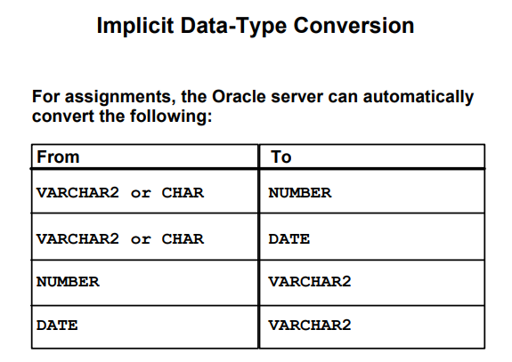
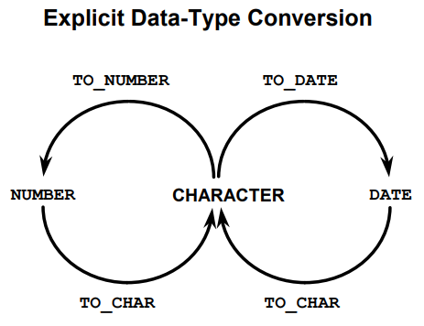

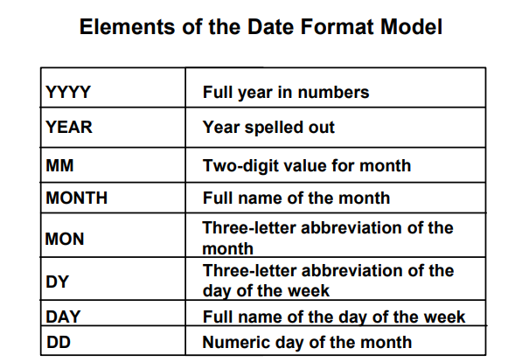
TO_DATE:
SELECT TO_DATE('January 15, 1989','Month dd, YYYY' FROM DUAL;
Insert into testdate values (To_DATE('10-13-20','mm-DD-YY'));
Insert Into testdate values (11-10-2020)
Insert Into testdate values ('11-10-2020')
Insert Into testdate values (To_date('11-10-2020','dd-mm-yyyy'))
Insert into testdate values (To_DATE('10-13-20','mm-DD-YY'));
TO_CHAR:
SELECT TO_CHAR(sysdate,'mm/dd/yyyy') from dual
select To_char(Hire_date,'mm/dd/yyyy') from employees
select To_char(Hire_date,'mm/dd/yyyy') Hiredate, TO_CHAR (salary, '$99999.99') Salary from employees.

GENERAL FUNCTIONS:
- NVL
- NVL2
- NULLIF
- COALSCE
NVL:
Used to return actual value or NULL value
Requires 2 expressions
NVL(expr1,expr2):
select last_name, commission_pct An_salary from employees
select last_name, NVL(commission_pct, 0) An_salary from employees
select last_name, NVL(commission_pct, 0), (salary*12)+(salary*12*NVL(commission_pct, 0)) An_salary from employees

NVL2:
Requires 3 expression.
Returns 2nd expression if 1st is not null and returns 3rd expression if first is null
NVL2(expr1,expr2,expr3):
select last_name, salary, commission_pct, salary*commission_pct, NVL2(Commission_pct,(salary*commission_pct)*12,salary*12) income from employees

NULLIF:
Requires 2 expressions
Compares values in two columns and returns the null value if both are equal, if not equal it will return value of first column
NULLIF(expr1, expr2):
select first_name,Length(first_name) expr1, last_name, length(last_name) expr2, NULLIF(Length(First_name), Length(Last_name)) result from employees

COALESCE:
Accepts n number of expression and It will return first not null value
COALESCE(Manager_Id,Commission_pct, Salary)
select last_name, COALESCE(Manager_Id,Commission_pct, - 1) comm from employees
select last_name, Manager_Id,Commission_pct, salary from employees where last_name='King'
select * from employees where last_name='King'

